1)Prompt for amount, interest rate and no. of years and calculate simple interest.

<html>

<head>

<script type="text/javascript">

var a=prompt("Enter Amount:");

var r=prompt("Interest Rate:");

var n=prompt("No. of years:");

alert("Simple Interest :" + a\*r\*n/100);

</script>

</head>

<body>

</body>

</html>

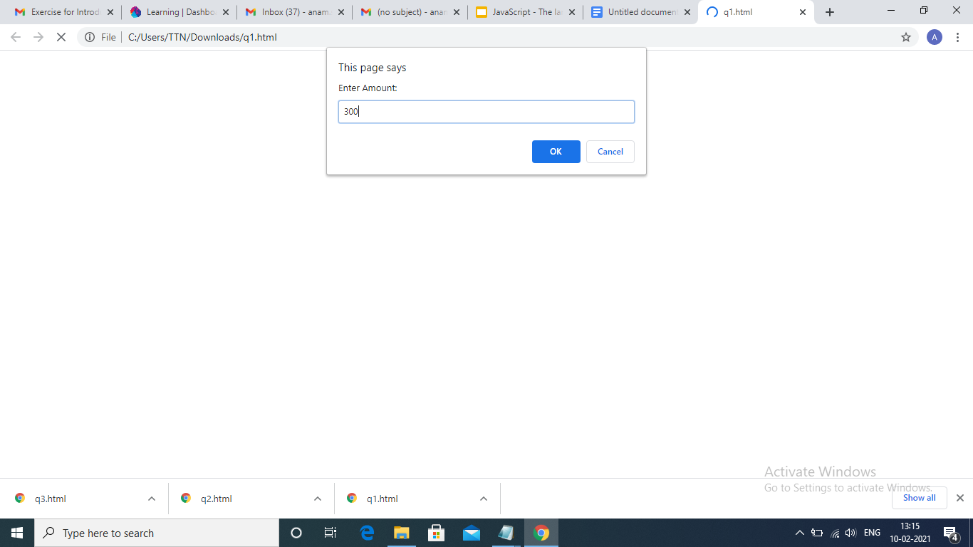

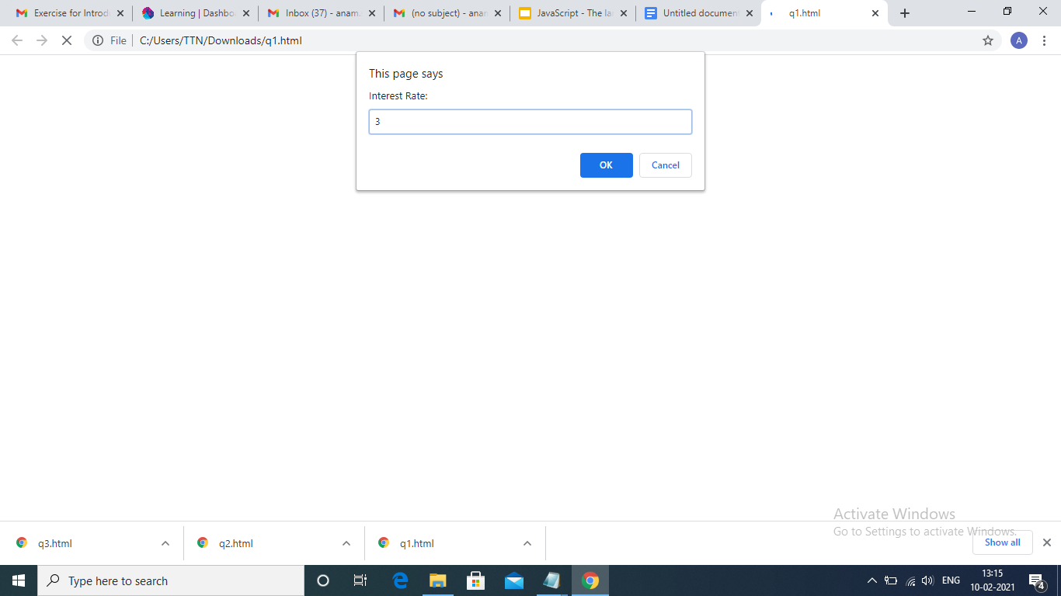

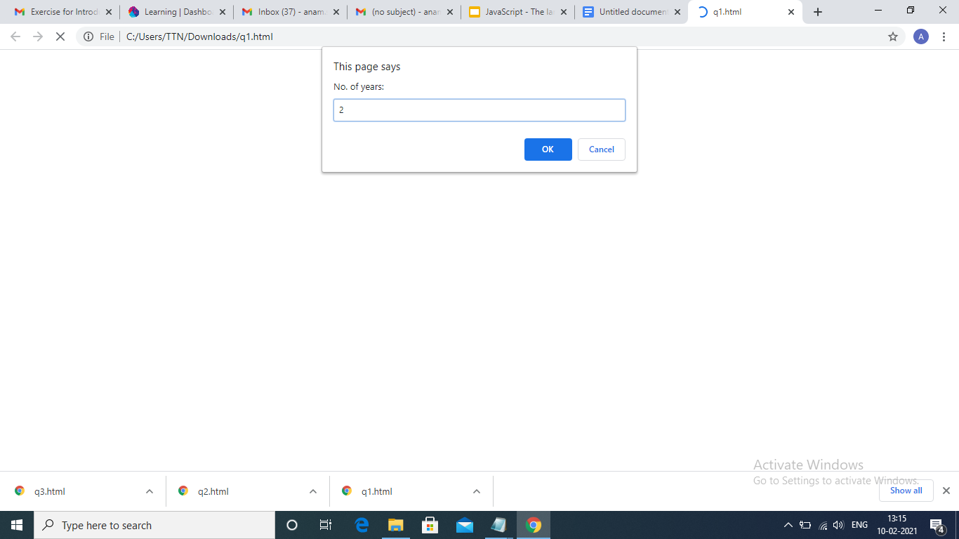

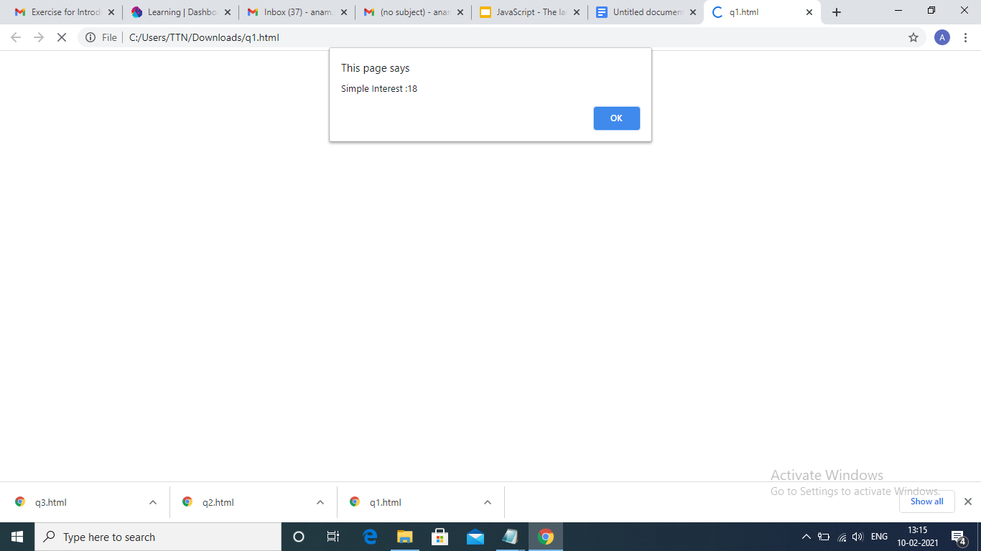

2)is palindrome string

<html>

<head></head><body>

Enter Any string:<input type="text" id="a"> <br>

<p> Result string:<input type="text" id="b"><br>

<p><input type="submit" onclick="pal()">

<script type="text/javascript">

function pal()

{

var x=document.getElementById("a").value;

var y="";

for(i=x.length-1;i>=0;i--)

{

y=y+x[i];

}

if(x==y)

document.getElementById("b").value= x +" Is a Palindrome ";

else

document.getElementById("b").value= x +" Is Not a Palindrome";

}

</script></body></html>

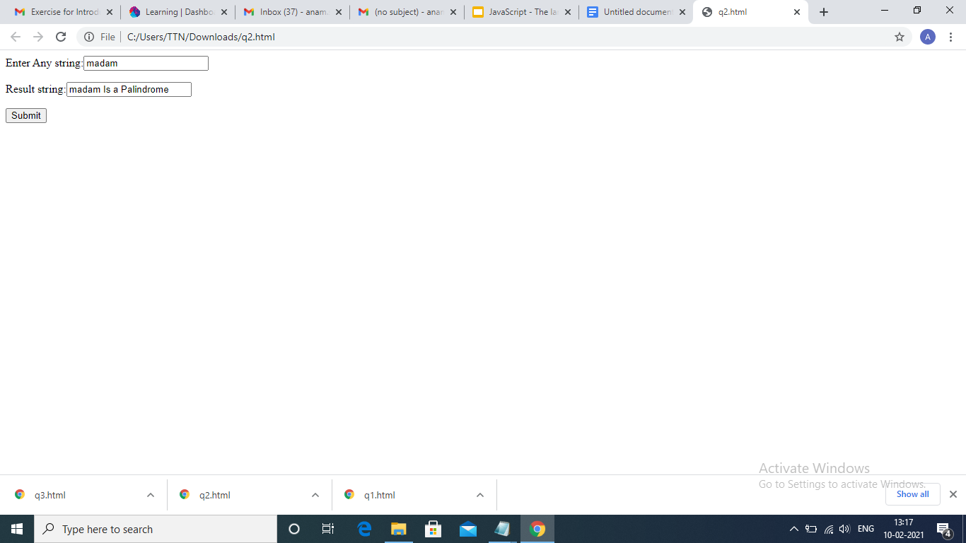

3)Area of circle

<html>

<head>

<title>Find the area of a circle</title>

</head>

<body>

<script language="JavaScript">

function CalculateArea(){

var radius =document.form1.txtRadius.value;

document.write("<P>The area of the circle is " + (radius \* radius \* Math.PI) + "</p>"); }

</script>

<form name=form1>

Enter the radius of circle:

<input type="text" name="txtRadius" size=10>

<br>

<input type="button" value="Calculate" onClick='CalculateArea();'>

</form>

</script</body></html>

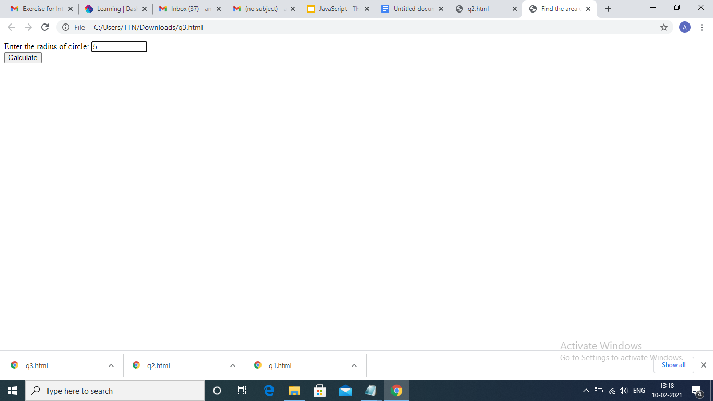

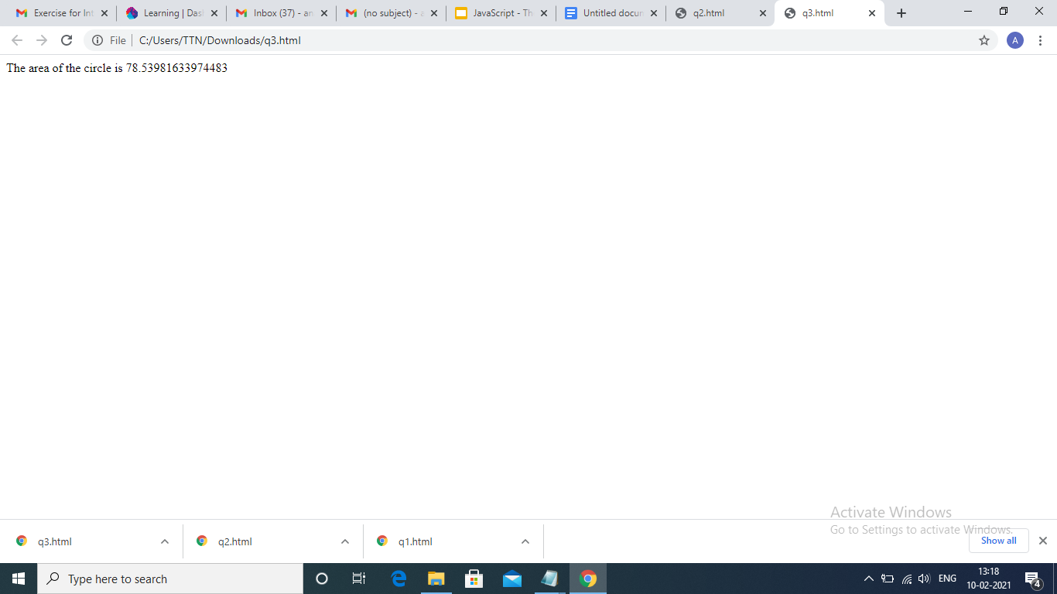

4)Copy information of one object to another and log it to console

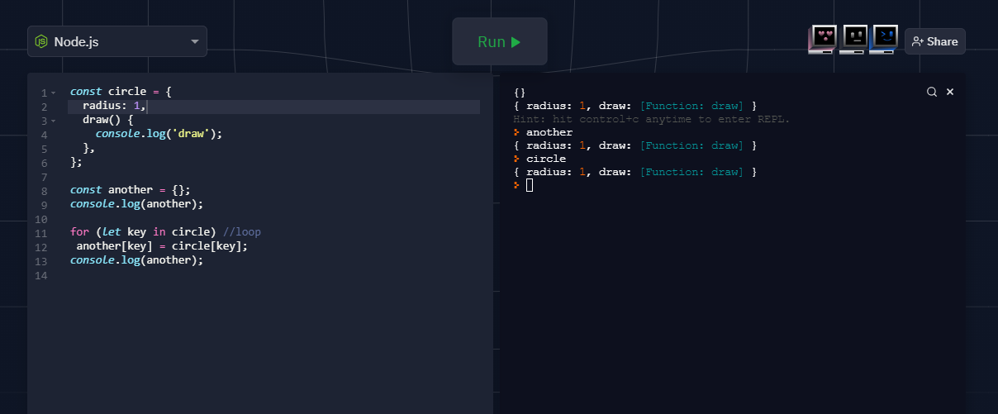.

5)create a list of objects of Employee with info as follow :

* Name, age, salary

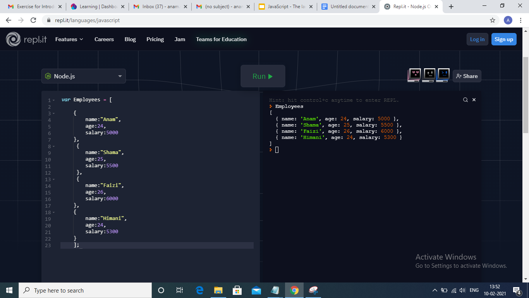

* filter all employees with salary greater than 5000

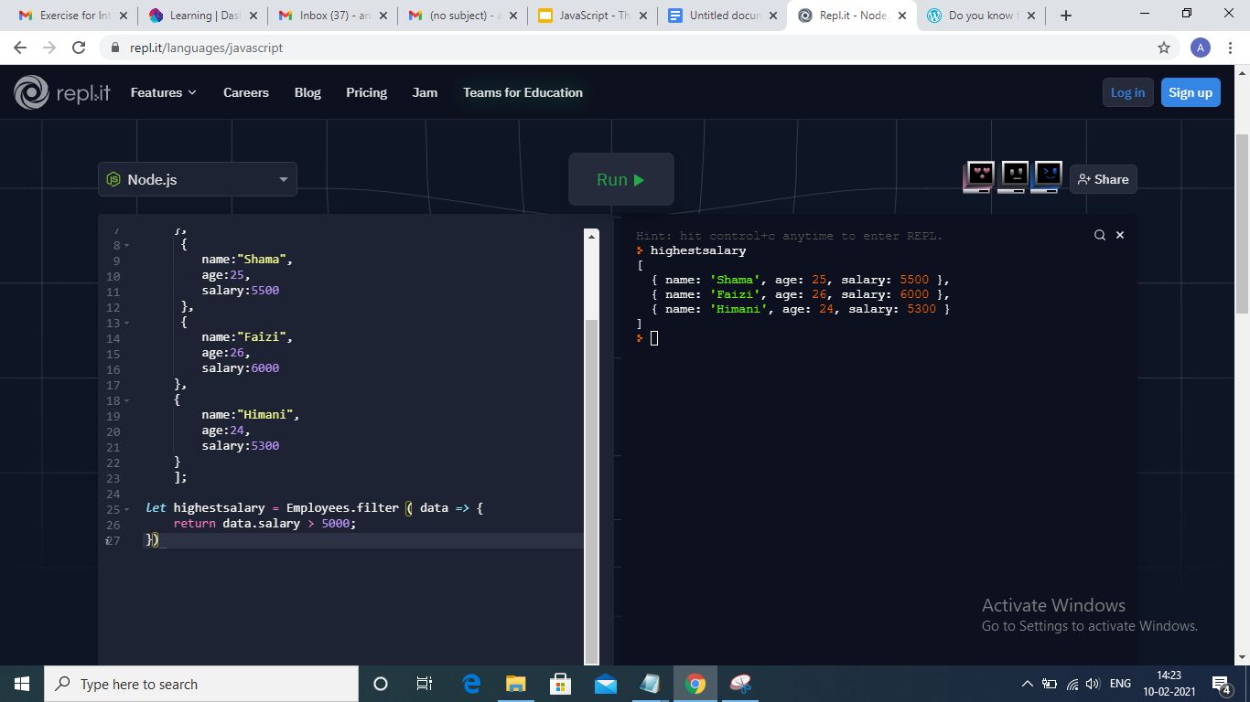

* group employee on the basis of their age

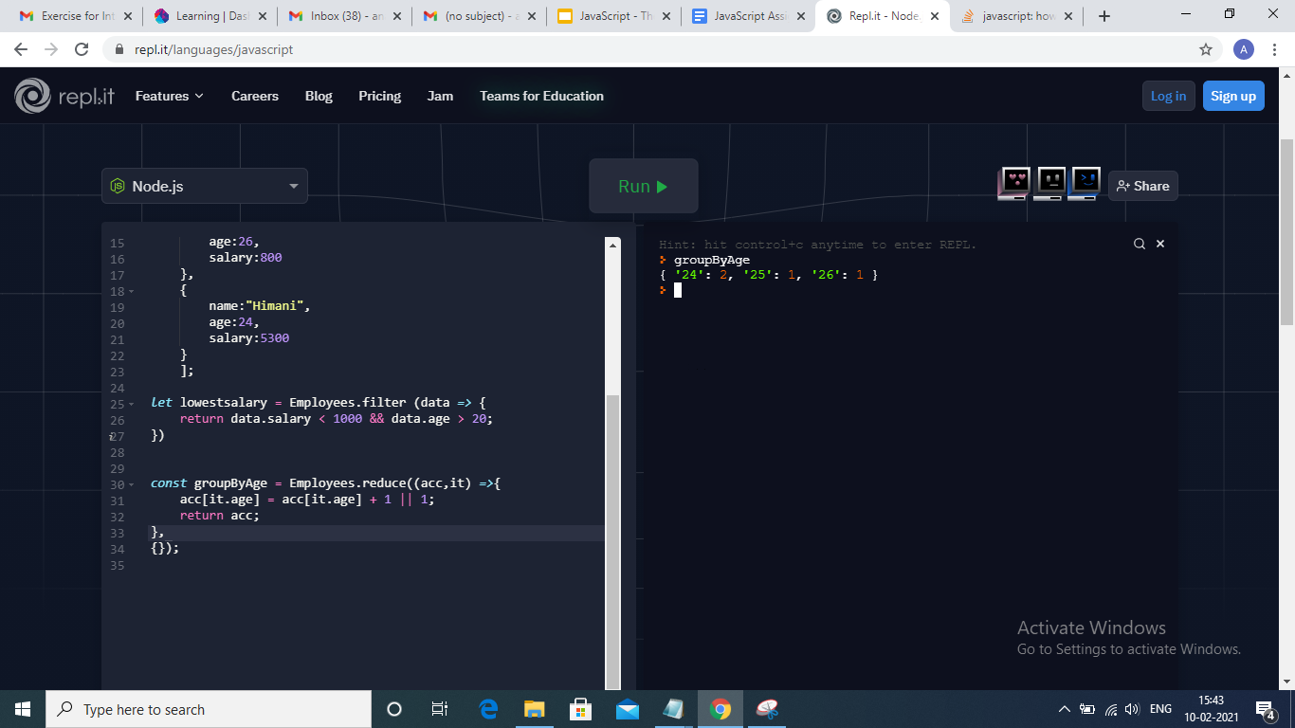

* fetch employees with salary less than 1000 and age greater than 20. Then give them an increment 5 times their salary.

